**Virtual Local Area Network (VLAN)**

**Designed Topology:**

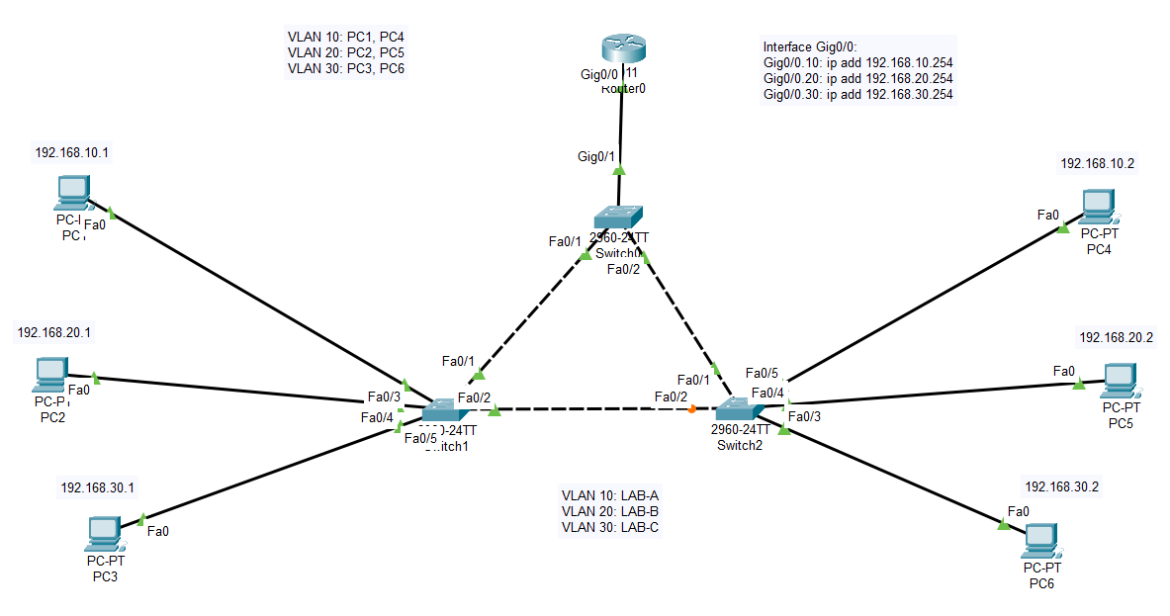

**Configuration of Switch1:**

Switch>enable

Switch#config terminal

Switch(config)#hostname SW1

SW1(config)#vlan 10

SW1(config-vlan)#name LAB-A

SW1(config-vlan)#exit

SW1(config)#vlan 20

SW1(config-vlan)#name LAB-B

SW1(config-vlan)#exit

SW1(config)#vlan 30

SW1(config-vlan)#name LAB-C

SW1(config-vlan)#exit

SW1(config)#interface fa0/3

SW1(config-if)#switchport mode access

SW1(config-if)#switchport access vlan 10

SW1(config-if)#exit

SW1(config)#interface fa0/4

SW1(config-if)#switchport mode access

SW1(config-if)#switchport access vlan 20

SW1(config-if)#exit

SW1(config)#interface fa0/5

SW1(config-if)#switchport mode access

SW1(config-if)#switchport access vlan 30

SW1(config-if)#exit

SW1(config)#interface fa0/1

SW1(config-if)#switchport mode trunk

SW1(config-if)#exit

SW1(config)#interface fa0/2

SW1(config-if)#switchport mode trunk

SW1(config-if)#exit

SW1(config)#exit

SW1#write

**Configuration of Switch2:**

Switch>enable

Switch#config terminal

Switch(config)#hostname SW2

SW2(config)#vlan 10

SW2(config-vlan)#name LAB-A

SW2(config-vlan)#exit

SW2(config)#vlan 20

SW2(config-vlan)#name LAB-B

SW2(config-vlan)#exit

SW2(config)#vlan 30

SW2(config-vlan)#name LAB-C

SW2(config-vlan)#exit

SW2(config)#

SW2(config)#interface fa0/3

SW2(config-if)#switchport mode access

SW2(config-if)#switchport access vlan 30

SW2(config-if)#exit

SW2(config)#interface fa0/4

SW2(config-if)#switchport mode access

SW2(config-if)#switchport access vlan 20

SW2(config-if)#exit

SW2(config)#interface fa0/5

SW2(config-if)#switchport mode access

SW2(config-if)#switchport access vlan 10

SW2(config-if)#exit

SW2(config)#interface fa0/1

SW2(config-if)#switchport mode trunk

SW2(config-if)#exit

SW2(config)#interface fa0/2

SW2(config-if)#switchport mode trunk

SW2(config-if)#exit

SW2(config)#exit

SW2#write

**Configuration of Switch0:**

Switch>enable

Switch#config terminal

Switch(config)#hostname SW0

Switch(config)#vlan 10

SW0(config-vlan)#name LAB-A

SW0(config-vlan)#EXIT

SW0(config)#vlan 20

SW0(config-vlan)#name LAB-B

SW0(config-vlan)#exit

SW0(config)#vlan 30

SW0(config-vlan)#name LAB-C

SW0(config-vlan)#exit

SW0(config)#interface fa0/1

SW0(config-if)#switchport mode trunk

SW0(config-if)#exit

SW0(config)#interface fa0/2

SW0(config-if)#switchport mode trunk

SW0(config-if)#exit

SW0(config)#interface Gig0/1

SW0(config-if)#switchport mode trunk

SW0(config-if)#exit

SW0(config)#exit

SW0#write

**Configuration of Router:**

Router>enable

Router#config terminal

Router(config)#interface gi0/0

Router(config-if)#no shutdown

Router(config-if)#exit

Router(config)#interface gi0/0

Router(config-if)#int gi0/0.10

Router(config-subif)#encapsulation dot1Q 10

Router(config-subif)#ip address 192.168.10.254 255.255.255.0

Router(config-subif)#exit

Router(config)#interface gi0/0

Router(config-if)#int gi0/0.20

Router(config-subif)#encapsulation dot1Q 20

Router(config-subif)#ip address 192.168.20.254 255.255.255.0

Router(config-subif)#exit

Router(config)#interface gi0/0

Router(config-if)#int gi0/0.30

Router(config-subif)#encapsulation dot1Q 30

Router(config-subif)#ip address 192.168.30.254 255.255.255.0

Router(config-subif)#exit

Router(config)#exit

Router#write

**Checking Connectivity by Pinging:**

